Via Instruction
Download and Install Via App
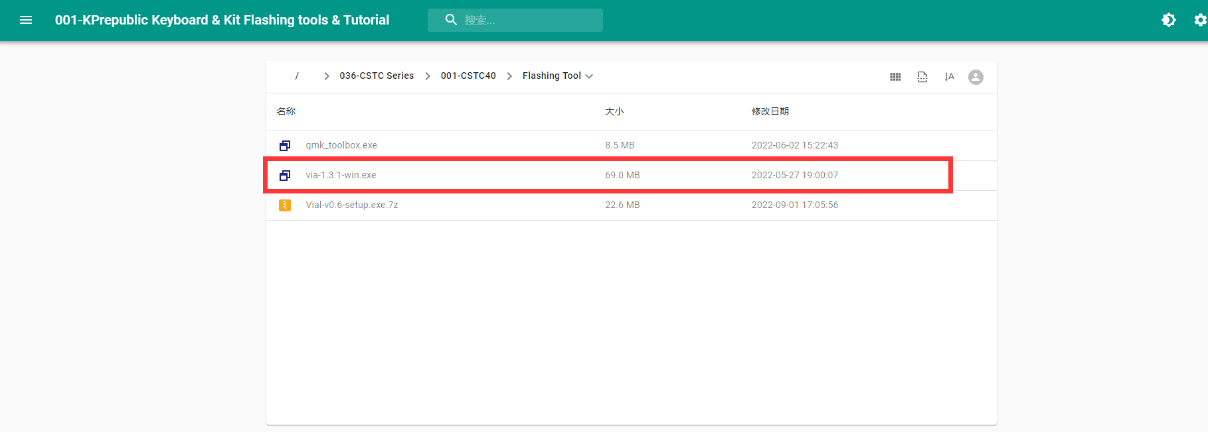
Go to KPrepublic Drive to download ViaL.exe
If you have the Browser download Block notification, please kindly approve the software passing your firewall. It doesn’t mean the software has malware.

Upload .json file
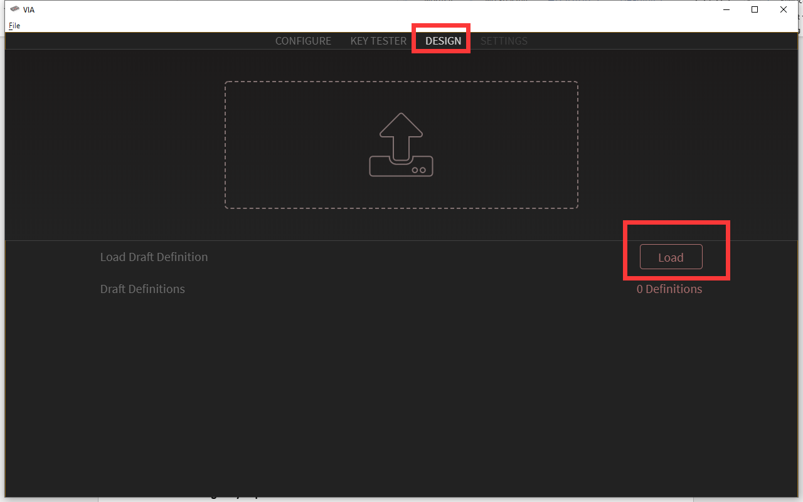
Open VIA software, go to Design tab, then load CSTC40 json file (which you can download from kprepublic drive)
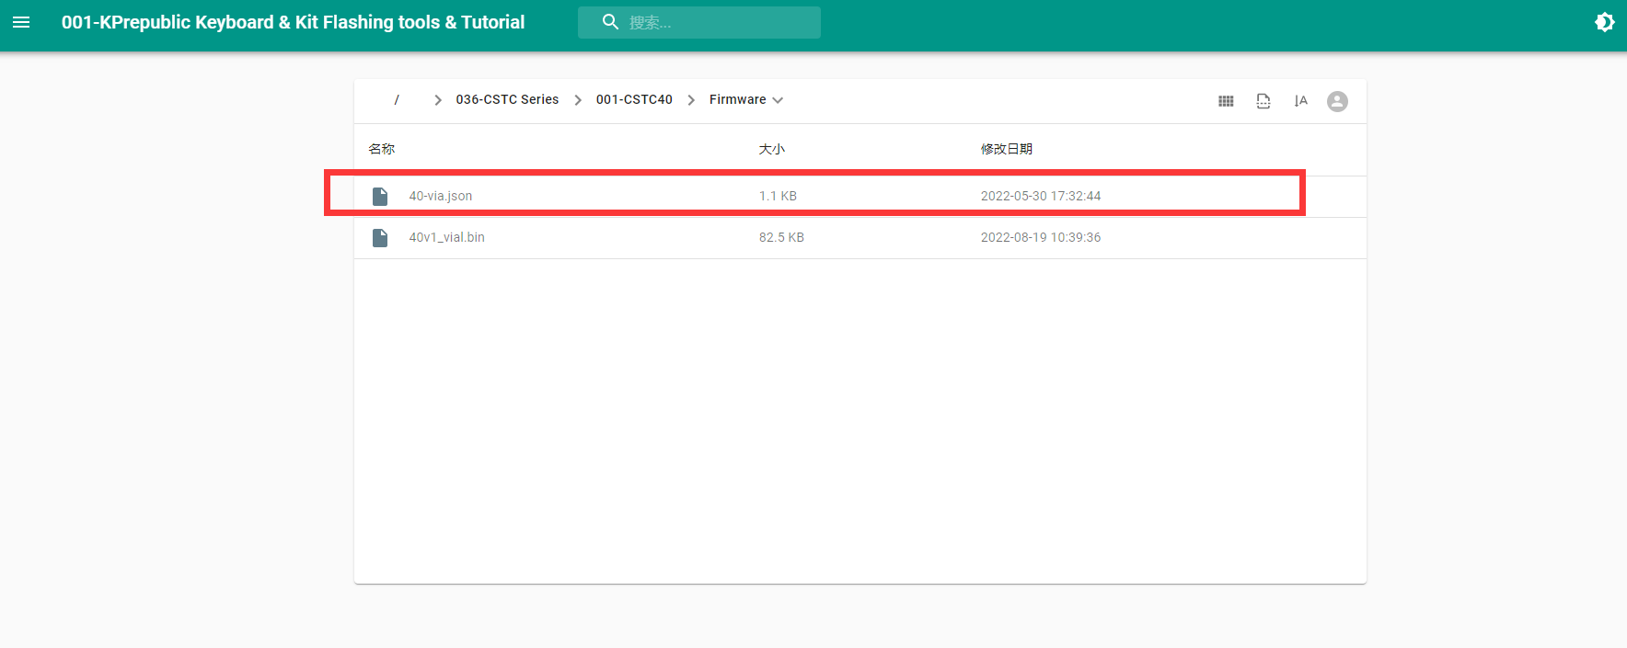

Change keymap
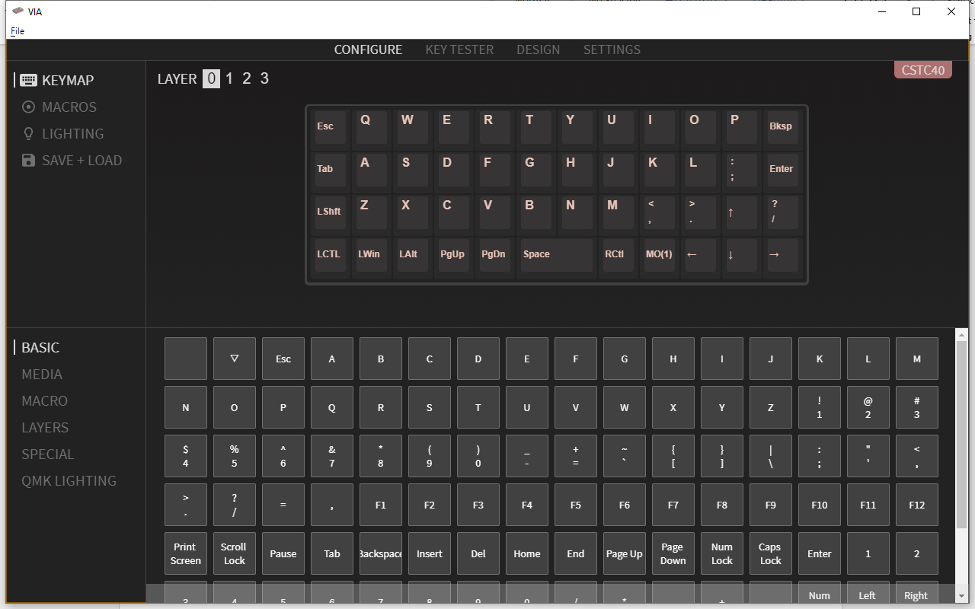
After loading the json file, back to Configure tab, the CSTC40 layout will come out. Then, you can change your keymap now.

